Batch: A-3 Roll No.: 16010122104
Experiment No. 7
Grade: AA / AB / BB / BC / CC / CD /DD

Title: Implementation of Containers and Dockers

Objective:
Docker installation on machine.

Expected Outcome of Experiment:

CO | Outcome
CO4 | Build cloud services and applications

Books/ Journals/ Websites referred:

Abstract:-
Docker is a container management service that was initially released in March 2013. It has become a cornerstone technology in modern software development, particularly for Agile-based projects. Docker's main features include the ability to develop, ship, and run applications anywhere, providing developers with a streamlined way to package applications into containers that can be deployed in various environments.
Related Theory: -
Core Concepts of Docker
What is a Container?
Containers are an abstraction at the application layer that packages code and dependencies together. They provide a standardized way to bundle an application's code, runtime, system tools, libraries, and settings into a single object. Unlike virtual machines, containers share the host system's kernel and run as isolated processes in user space.

A container is a runtime instance of an image—what the image becomes in memory when executed. It runs completely isolated from the host environment by default, only accessing host files and ports if configured to do so.

Docker Architecture
The Docker architecture consists of several key components:

Docker for Mac/Linux/Windows: Platform-specific applications that allow running Docker containers on different operating systems

Docker Engine: Used for building Docker images and creating Docker containers

Docker Hub: A registry used to host various Docker images

Docker Compose: Used to define applications using multiple Docker containers

Containers vs. Virtual Machines
While both containers and virtual machines provide isolation, they differ significantly in their approach:
Feature | Containers | Virtual Machines
Size | Typically tens of MBs | Often several GBs
Startup time | Almost instant | Minutes
Resource usage | Minimal overhead | Significant overhead
OS | Share host OS kernel | Run complete guest OS
Isolation | Process-level isolation | Hardware-level isolation
Performance | Near-native performance | Virtualized access to resources

Containers run apps natively on the host machine's kernel, providing better performance characteristics than virtual machines that only get virtual access to host resources through a hypervisor.

Benefits of Docker Containers
Resource Efficiency
Containers are lightweight and take up less memory than any other executable. Multiple containers can run on the same machine and share the OS kernel with other containers, each running as isolated processes in user space.

Improved Portability
Docker aims to facilitate developers to easily develop applications, ship them into containers, and then deploy them anywhere. This "build once, deploy anywhere" approach eliminates the common "works on my machine" problem when collaborating on code.

Better Collaboration
With containers, it becomes easier for software teams, such as development, QA, and operations, to work seamlessly across applications. Containers provide a consistent environment across different stages of development.

Enhanced Scalability
Since Docker containers are lightweight, they are very easily scalable. You can deploy Docker containers anywhere, on any physical and virtual machines, and even on the cloud.

Isolation and Security
Each container runs isolated tasks and cannot harm the host machine nor conflict with other applications running in separate containers. This isolation enhances security by containing potential vulnerabilities within individual containers.

Docker Components and Workflow
Docker Images
An image is a lightweight, stand-alone, executable package that includes everything needed to run a piece of software, including the code, runtime, libraries, environment variables, and configuration files. Images are built using a Dockerfile, which contains instructions for creating the image.

Dockerfile
A Dockerfile is a script that contains a series of instructions for creating a Docker image automatically. It can be versioned in a version control system like Git or SVN, along with all dependencies.

Docker Hub
Docker Hub is a public repository of Docker images (https://hub.docker.com). It offers automated builds where images can be automatically built from Dockerfiles on GitHub.

Basic Docker Commands
images: List all local images

run: Create a container from an image and execute a command in it

tag: Tag an image

pull: Download image from repository

rmi: Delete a local image

ps: List all running containers

ps -a: List all containers including stopped ones

start: Start a stopped container

stop: Stop a running container

pause: Pause all processes within a container

rm: Delete a container

commit: Create an image from a container

Container Orchestration
For managing multiple containers, especially in production environments, container orchestration tools like Kubernetes are commonly used. These tools help with:

Automating container deployment

Scaling containers up or down

Load balancing

Managing container networking

Ensuring high availability

Operating System Level Virtualization
Docker implements operating system-level virtualization, where the kernel of an OS allows more than one isolated user-space instance to exist. This approach:

Overcomes issues of redundancy when the physical and virtual OSs are the same

Imposes little or no overhead

Is capable of live migration

Can use dynamic load balancing of containers between nodes and a cluster
Implementation Details:
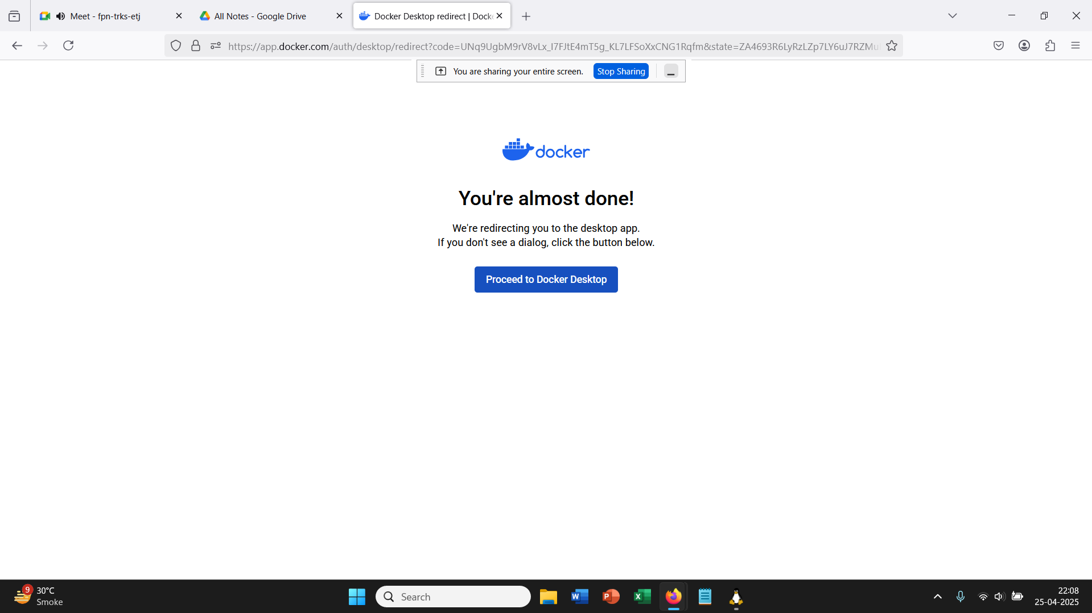
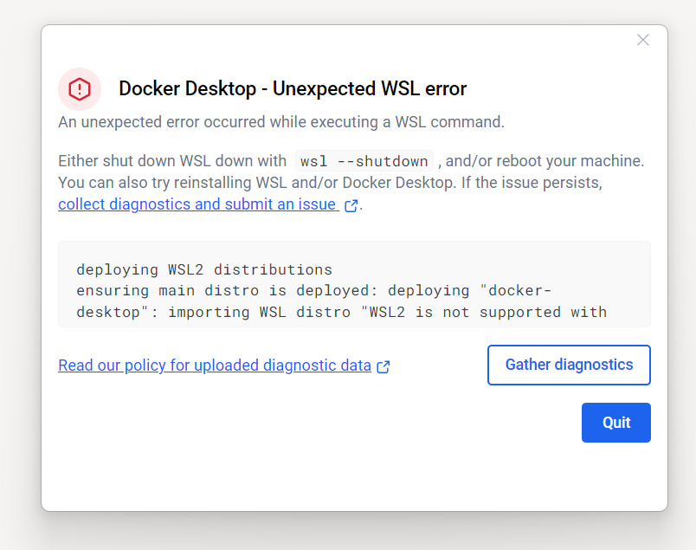
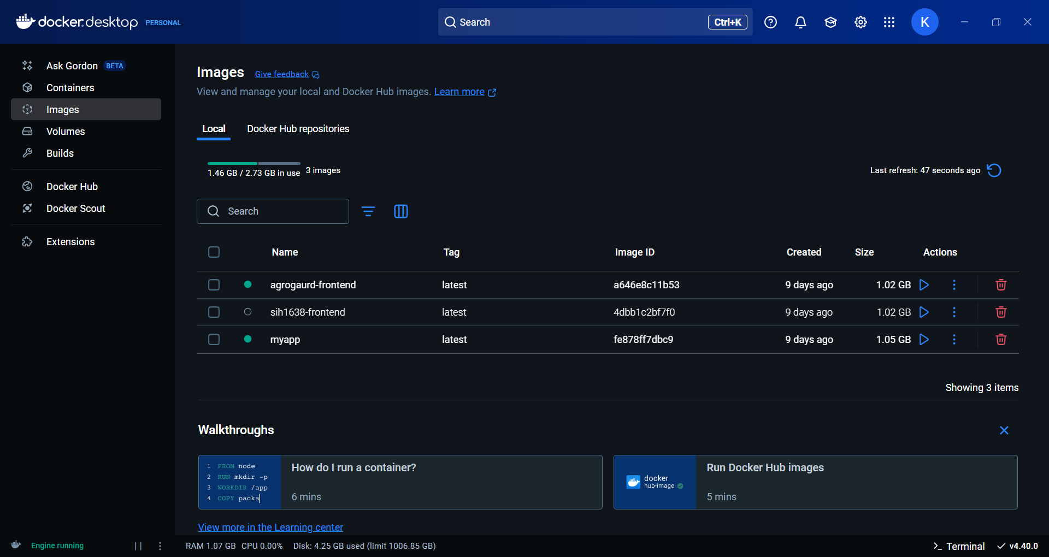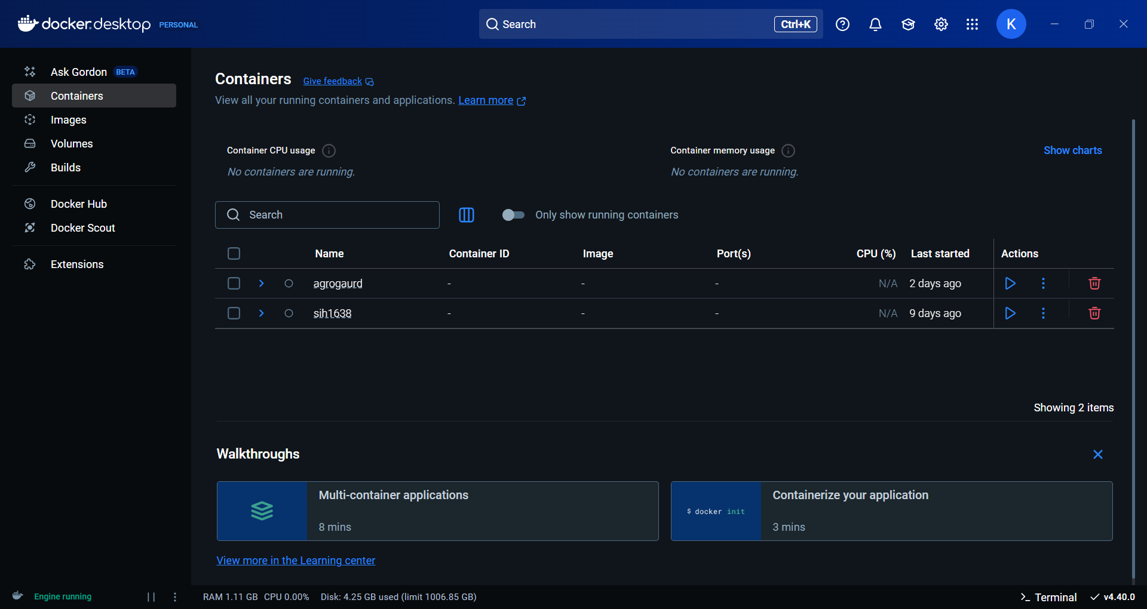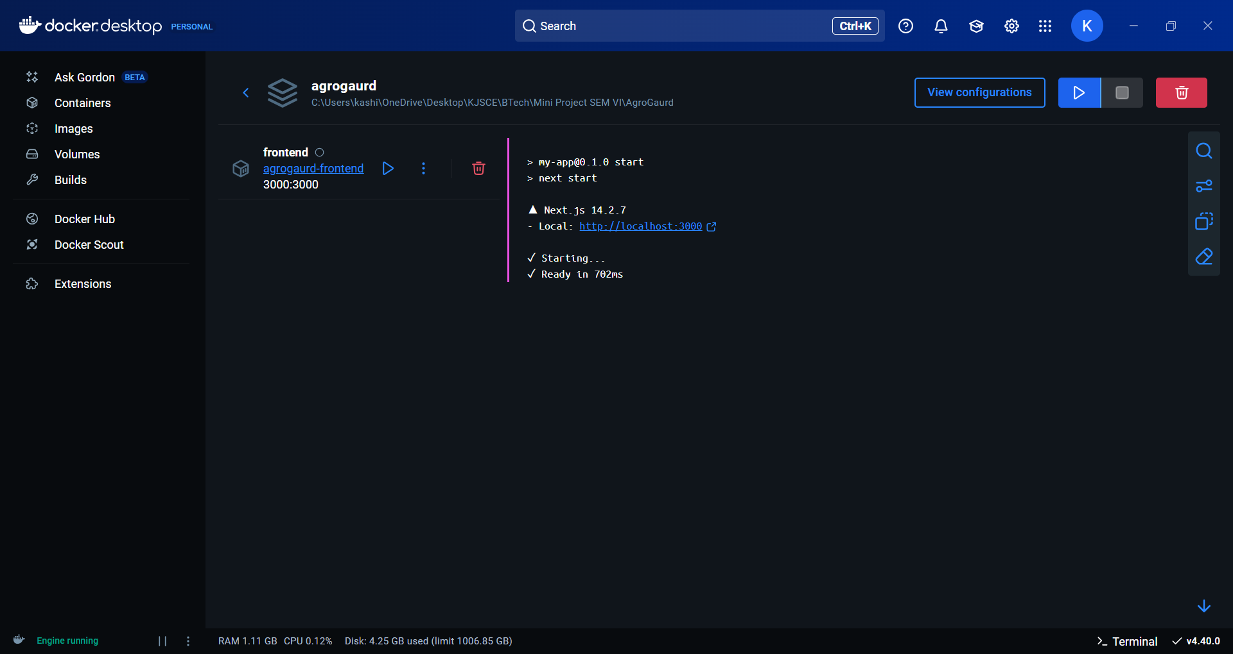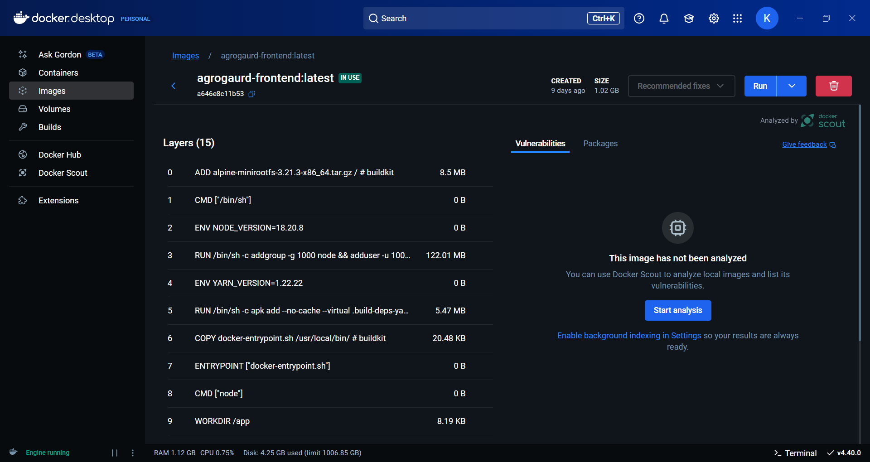

Conclusion:-
Docker containers have revolutionized application development and deployment by providing a consistent, portable, and efficient way to package and run applications. Their lightweight nature, combined with the ability to run anywhere, makes them an essential tool in modern cloud computing and DevOps practices.
As containerization continues to evolve, Docker remains at the forefront, enabling developers to build, ship, and run distributed applications with unprecedented ease and efficiency.

